Name Class

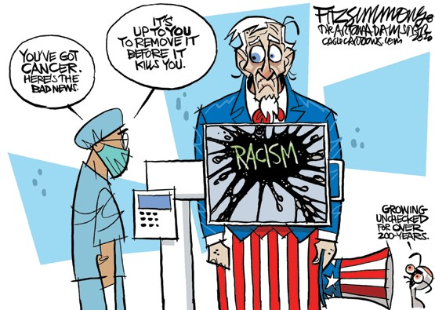

**CARTOON ANALYSIS For use with “Two Americas” on p. 8 of the magazine**

**DAVID FITZSIMMONS • *THE ARIZONA STAR* • CAGLECARTOONS.COM**

Scholastic Inc. grants Teacher-Subscribers to *The New York Times Upfront* permission to reproduce this Skills Sheet for use in their classrooms. ©2020 by Scholastic Inc. All rights reserved.

Analyze the Political Cartoon **(Cartoon appears on p. 24 of the magazine.)**

1. **Who is the central figure in the cartoon? Which details help you identify him? What does this iconic figure symbolize?**
2. **What is the setting of the cartoon? What is happening in the cartoon?**
3. **What diagnosis does the doctor make? What kind of cancer does Uncle Sam have? Why has it gotten to the stage where it could kill Uncle Sam?**
4. **Examine Uncle Sam’s face. What does his expression reveal about his reaction to the doctor’s news?**
5. **What do you think is the cartoonist’s message about racism in the U.S.?**

**O C TO B E R 1 2 , 2020 • UPFRONTMA G AZINE. C OM**

